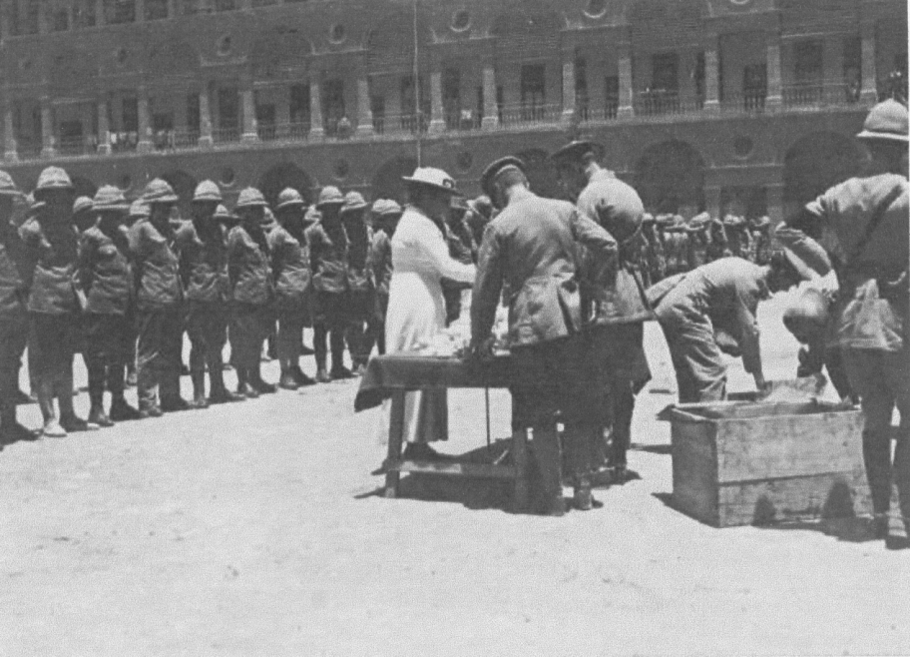

The National Library of Australia, **Trove** website has this photo on display, the image is identified as being ‘*Distribution to Anzac Provost Corps, Cairo.’* The photograph is acknowledged as being from the Great War, I believe the occurrence may well have also been basis for the newspaper article shown below (the article was also sourced through **Trove**).

*Now the* ***Anzac******Provost******Corps****, alias "The Thankless Job" is a development; necessity produced it. - Its members have what, is termed scathingly by the fighters "a soft job." Materially, - of course, contrast to the wild orgies of the terrible battlefield, this might be so, - But morally, it is the most fiendishly difficult and distasteful task ever invented. It consists primarily in keeping any of their mates (those who have the inclination to do so) from making fools of themselves in the eyes of the natives and numberless alien races of Egypt; and secondarily in the enforcing of a hundred petty irksome rules of military discipline. All this has to be done to one's own flesh and blood - one's "mates." Just there's the rub.*

*Thus the A.P.C. boys - doing their thankless but essential duty - are branded by the headstrong as undiscerning as publicans, Judases, traitors to their mates for reporting them, and a thousand other far firey epithets, and are looked upon by the great majority of "fighters” as "cold-footed loafers."*

*But the dear old Australian Comforts' Fund (of which the Tasmanians Active Service fund is the Tasmanian division) pauses at nothing of this. With deep comprehension - like the wise, loving mother that she is to all her children the goes directly to the heart of the matter. These are her boys, doing their stern duty just as much as any on the battlefield. She knows of the B class men, once wounded, that the corps contains; she knows of the few who are volunteers (and most of their reasons for volunteering, too), and knows also the large number that have merely received orders to quit their units and become "****Anzac Provost Corps****." She knows, too, the long hard hours of keeping guard in filthy slums, watching for any poor disreputable mate; or standing at street corners, hotel vestibules, theatre entrances, in, hot baking sun or in the cold night wind, on guard to prevent any flaws in military discipline-to up- hold their country's name.*

*She remembers to, many invaluable detective feats achieved by faithful concentrated observation. Above all, these, her boys in khaki need her "comforts." And it is the boys' need every time that has the strongest pull on her heartstrings.*

*So the Australian Comforts' fund grey motor suddenly appears at the barracks one forenoon - those comfortless, ancient style, dreary barracks (near enough to the Nile for the ground floor to become exceedingly damp during each year’s overflow). Its occupant, Miss McConaghy, finds out how many boys are quartered there in the barracks, takes a general survey of the "lay of the land," and the very next day several cases of welcome, unaccustomed comforts arrive.*

*A very - willing parade of the A.P.C. is then called; Q.M.S. Edmonds gets very busy carefully arranging the gifts on the table for distribution; Sergeant Major Stevens takes two good snapshots, and then the Australian Comforts Fund (in other words. Miss McConaghy) has its heart's desire. For each boy (such fine, big, clean-looking follows the A.P.C are) marches past and receives his share of the gifts into his own hands just for himself.*

*When all is over, and three, happy cheers have resounded through the old cloister-like arches all round the square yard, the little grey motor doesn't seem to have any idea of returning to its quarters somehow; there is something on its mind apparently: "Have you any men in there?" asks Miss McConaghy, pointing to the "clink." "Yes," replied the O.C. "Aren't they to get anything?" asks she quietly. "Yes, certainly, if you wish it," responds the O.C. with -unexpected heartiness, "and you may give them some comforts yourself." "Hear, hear," ejaculated the happy little grey motor standing patiently at one side watching proceedings. "Kindness softens; it never, can harm," it added sedately. An Australian Comforts' Fund motto that, and the O.C. felt it.*

*So right into the "defaulters" quarters the comforts, those subtle reminders of home, entered. And their influence, who would dare to estimate it? Not even themselves could do so.*

*"There was one thing that the A.P.C. that thankless, trying job-could thoroughly estimate, however, and that was just how warm Australia's affection for her sons could be. For there is no corner upon this earth - wherever the boys are doing their stern duty - into which the Australian Comforts' Fund has not penetrated. It has always reminded me of the influence of the sun.*

It is not hard to deduce that the above article that was reproduced in *The Mercury* (Hobart) on Friday 22nd June 1917, could well relate to the photo shown at the start of the article. The barracks in the photo are most certainly the Kasr-el-Nil Barracks, a portion of which was the home of the Cairo Detachment for the Anzac Provost Corps. It is easy to imagine that QMS Stevens is one of those fussing around organising the distribution of parcels, ready to give to the men.

The photographer logically may well be Sergeant Major Stevens, as Miss McConaghy stated in her description. A further indication that the article and photo relate, is that the Kasr-el-Nil Barracks was located right next to the Nile, indeed in the following photograph a portion of the Anzac Provost Corps are shown crossing the Kasr-el-Nil Bridge, possibly the photo is taken from one of the upper level of the nearby barracks?

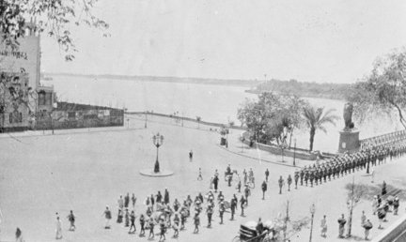

Miss McConaghy’s view about most of the men in the Anzac Provost Corps is not necessarily correct, the bulk of the corps had come together at Abbassia in Egypt in early April 1916 and it had been a call for volunteers, **no** forced secondments were made. Those that were found to be unsuitable for the role were returned to their original units and those that found the role also not to their liking were given the opportunity to transfer to other units. Of course there were exceptions to these rules, the Egyptian Section of the corps was known to have regularly seconded light horse squadrons to act as MMP, but more likely these men would have been akin to the traffic control detachments that assisted the MMP on the Western Front, these secondments were not more than a few weeks generally. The Cairo Detachment was not a mounted section and was probably more like the British MFP (military foot police) and in certain districts would have worked in conjunction with the British Military Police.

In saying this it is clear that many men still showed an allegiance to their original unit (quite rightly so) as often the men had seen service with that unit on the Gallipoli peninsula and many had been wounded there. As Miss McConaghy, stated many of these recovering wounded men were given the option to join the newly formed Anzac Provost Corps. Perhaps an embarrassment about the role they played, would lead many military policemen to infer they may have been somewhat reluctantly forced into that role. Indeed it is acknowledged that after the war many enquiries by ex-military policemen to the Department of Defence would quote their original unit’s service and barely mention their MP service, perhaps a realisation that the military police were not a loved force.

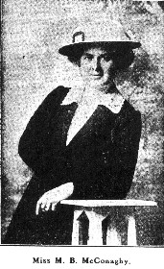Miss [McConaghy](http://www.nzetc.org/tm/scholarly/name-442993.html) had been engaged in missionary work in Palestine when Turkey declared war against the Allies, and instead of returning to her home in Ireland she remained in Egypt, realizing that there would be more need for workers there than in the United Kingdom. She was Hon. Lady Superintendent of the British Soldiers' Cafe during the first six months of its existence. When the wounded began to arrive from Gallipoli, she went into hospital and nursed until the evacuation, when there was no further need for extra workers. Miss McConaghy then interested herself in the Australian Comforts Fund. She was mentioned in dispatches for the work she did with the Australian Forces.

(Source The KIA-ORA COOEE magazine circa March 1918)

I draw from a passage often reproduced by the military police to illustrate an example of the provost corps early recruiting;

*Dear Elliot,*

*I was picked out of the 11/23 to join the ‘Anzac Provost Corps’ 15 of us were picked out of about three hundred, I was amongst those selected. We had to pass a severe test, the questions put to us were – had we ever crimed before or since joining H. Majesties Forces, and the length of service we had, what we returned to Australia with, and if we were in the habit of getting drunk. We also had to be over 5’9” and weighing 11 stone 10, my height and weight are now 13 stone 12 and 6”, so I had no trouble to get in and I could pass the other tests, I might say I have not touched strong drink since joining the Army, we have to be examined again tomorrow, but I don’t expect anything will put me out of them. The idea of getting picked men is to get a model corps of Australians to go to France we also do duty as military police, we are not ordinary MP’s, we are equipped with the same rifle and bayonet as the infantry and go into the trenches in France. I think by the time you get this I will very likely be there ( I hope so anyway) there are about 500 of us together here* [**Abbassia**] *and they are the pick of thousands, I have never seen a more even and splendid lot of men. The first person I saw here tonight was Bert Rosengrave, who used to work for Billy Fellows. I have to answer to roll call in a few minutes so I’ll stop, I hope to get this letter all right, it has to pass the censor yet, hoping all’s well. No 4562, ‘Anzac Provost Corps.*

*Your affect. Bro, Roy Argyle.*

The writer of the letter was Douglas Roy Argyle, better known as Roy. As hinted in his letter Roy had served on Gallipoli (with the 6th Battalion) and been evacuated due to Enteric Fever in late October. Roy had returned to Australia for a break and had re-enlisted in early March 1916, on this occasion he became part of the 11th re-enforcements for the 23rd Battalion.

Roy did finish his training and was ultimately was sent to France, but not as a divisional MMP, as he was describing in his letter, Roy appears to have served in the rear echelon areas and then later at the Field Punishment Compound. Private Argyle then transferred back to the 6th Battalion and became part of a Lewis Gun Crew in 11 Platoon within C Company, apparently he fitted back into the battalion quickly and was well liked.

Roy Argyle was killed in October 1917, Private Walden from the 6th Battalion described that he hadn’t actually seen Roy struck, but went to his aid afterwards, describing that Roy had been ‘shot through the abdomen’. Roy was wounded as his battalion advanced towards the Passchendaele Ridge early on the morning of 4 October 1917, Walden helped carry the unconscious Private Argyle back to a dressing station, but Roy died shortly after being admitted. Walden described that he was part of the Lewis Gun crew with Roy (Walden was the No 4, Argyle the No 2 on the gun).

Burt Rosengrave, who Roy mentioned, had also hailed from Kerang in Victoria; he was a few years older than Roy. Burt would serve with the provost corps throughout the war, in fact he spent most of his time posted to the Cairo Detachment, and he may well have been one of the military policemen lined up waiting to get his parcel.